# Introduction

Thank you for your interest in joining our team!

This written assessment is intended to help us understand how you think analytically and give you an opportunity to flex your technical skills. Please answer to the best of your ability - we understand that different candidates have different strengths, and we are using this as one piece of a holistic assessment.

There are 5 questions total: 3 technical questions and 2 open-ended questions. We expect this assessment to take no more than 2-3 hours to complete.

# Data Description

Please use the example data provided for all parts of this assessment. This data is fictional, but it is constructed to be similar to data we use daily. There are two related tables:

* *Contracts* describe “obligations”, which are dollars committed to purchasing goods and services at a later date. The customer retains some flexibility on timing and quantity of those purchases - for example, they may buy the full amount at a certain date or they may buy smaller amounts each month.
* *Transactions* describe “purchases” under a contract, where dollars are exchanged for products or services. Transactions are executed against an existing contract.

*Contracts* (5 columns, 10 rows)

| ContractID | Unique ID for the contract |
| --- | --- |
| Customer | Name of the customer agency |
| DollarsObligated | Amount of dollars obligated on this contract |
| Category | Type of products / services covered by the contract |
| Date | Date the contract was created in YYYY-MM-DD format |

*Transactions* (6 columns, 30 rows)

|  |  |
| --- | --- |
| TransactionID | Unique ID for the transaction |
| ContractID | ID of the contract the transaction was executed against |
| Price | Per-unit price of items purchased in dollars |
| Quantity | Number of units purchased in the transaction |
| Description | Free text description of the items purchased |
| Date | Date the transaction occurred in YYYY-MM-DD format |

# Technical Skills

For questions 1 - 3, please use a language or environment you’re comfortable with. If you are familiar with SQL or a statistical programming language, that is encouraged (particularly for question 1). Please include both your result and the code or work file you used to produce the result.

* You may copy/paste source code into the document or attach a separate file (e.g., Tableau .twbx, Jupyter Notebook .ipynb, Python .py, R .r, etc.)
* If you attach a file, please note the name of the file to reference for each response

Q1

Using the provided tables, please create the following table:

Each ContractID and number of transactions executed against that ContractID, ordered by descending count of associated transactions

Reminder - assume you have access to two tables:

* Contracts (containing all columns / data from Contracts data tab)
* Transactions (containing all columns / data from Transactions data tab)

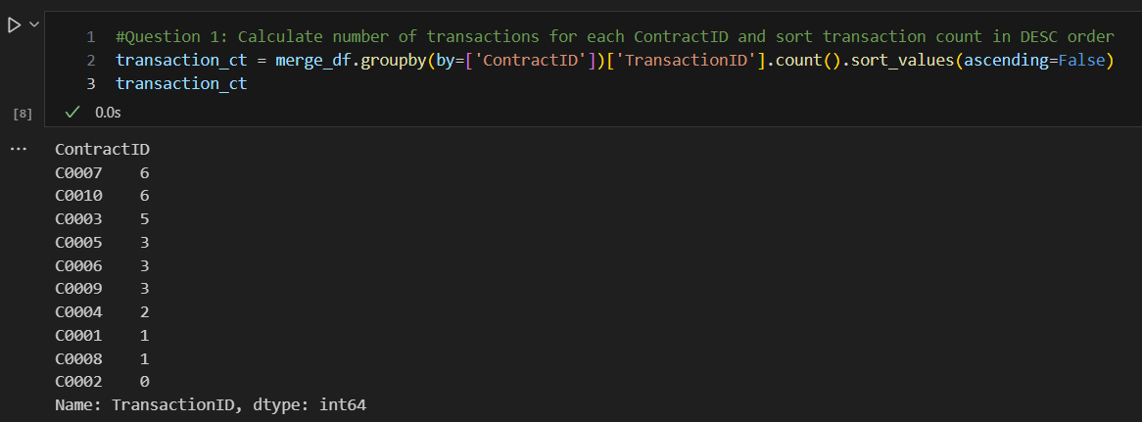

GSAAnalysis_202308 Bottom Section of Jupiter Notebook

Q2

What is the average dollar value for transactions on each day in March?

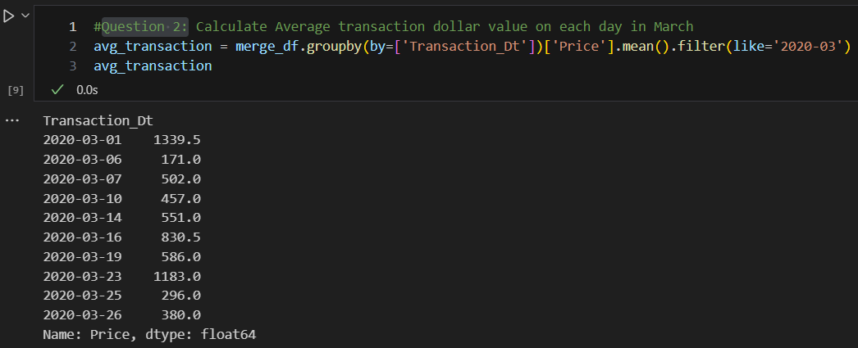

GSAAnalysis_202308 Bottom Section of Jupiter Notebook

Q3

For each customer, what percentage of their associated obligations have been spent as transactions?

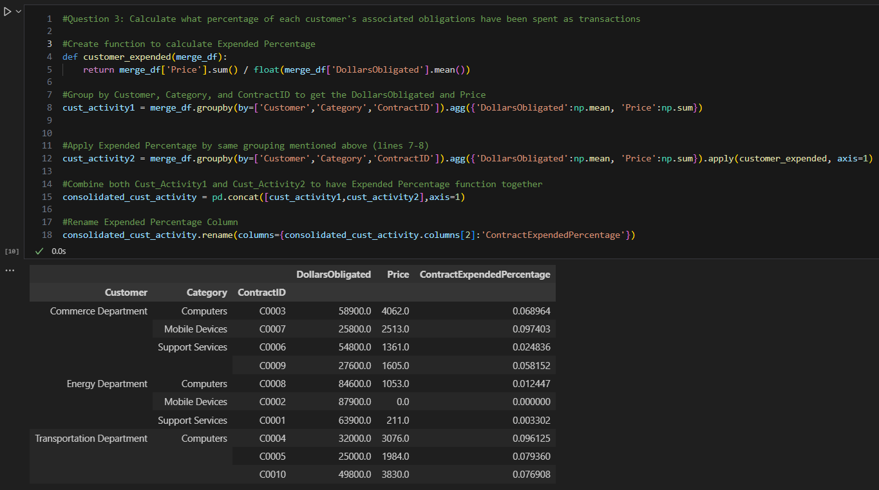

GSAAnalysis_202308 Bottom Section of Jupiter Notebook

# Open Ended - Visualization & Analysis

These questions are meant to be open-ended - there isn’t a right or wrong answer. Feel free to make any assumptions that might be helpful in creating your answer - but please make sure to state your assumptions in your answer.

Q4

Create a visualization which you think is interesting using the provided data, and provide an image below. Then, explain what the visualization shows and how it might be useful in a few paragraphs.

The visualization does not need to include all of the data - you may use a subset of columns and/or apply transformations to the columns. Please use whichever environment you are most comfortable with to create the visual.

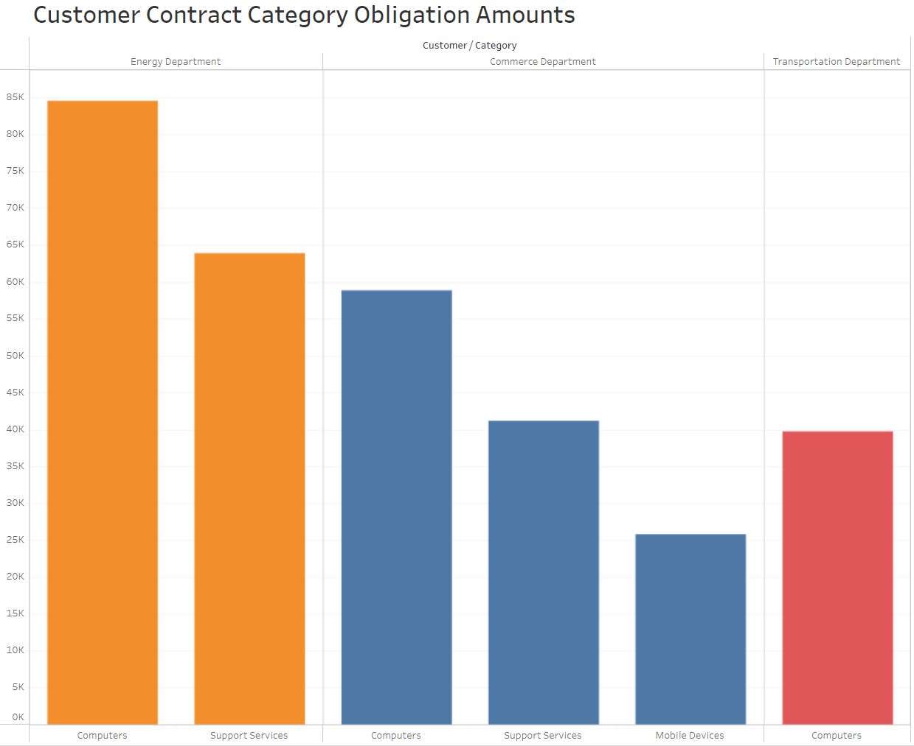

Explain what the visual shows and how it might be useful.

What are some key takeaways a viewer can use the visual to answer? This visual can help a user see the Contract Category amounts by each Federal Government Agency (Customer being serviced). This is especially helpful to understand how resources are being allocated in terms of services rendered to one’s customer base. Moreover, having this type of information can help decision makers understand the services that are in demand by their customers and maybe may lead GSA decision makers to formulate ways of marketing other types of services so that GSA’s service portfolio can be further diversified so that more types of Contract services are being requested.

For example, this visual shows that GSA has a few services contracts with the Department of Commerce and on the other extreme, only one with the Department of Transportation. Moreover, one can also recommend that we market more types of Contracts to the Department of transportation so that we have a more diversified customer portfolio. Lastly, one can see GSA’s two most popular Contract Categories (amount wise) are Computers and Support Services.

Q5

Describe a technical project or analysis that you think would be interesting to do with this data set, and briefly explain how you would implement it. Then, explain how the project or analysis might be useful for ITC.

For this question - please assume there is more data in both tables (thousands or millions of rows). You can also make any other assumptions that are helpful, but please state those assumptions. You do not need to implement the project or analysis.

<Part 1: Describe the technical project or analysis, and how it would be implemented. For example - What inputs / outputs does the model or analysis interact with? What language or environment would you use? Are there any technical or data requirements?>

I would connect my Jupyter Notebook or R Studio to a SQL database and extract datasets directly so that I can perform various forms of analysis without having to constantly export files from SQL database and then import them to conduct analysis.

<Part 2: Explain how the model / analysis might be useful. For example, what conclusions could you draw from the model / analysis? What does it mean if the model / analysis succeeds or fails? What business process or decision could you imagine using the model / analysis for?>

One type of analysis I would be interested in completing is trying to identify how have my Contract Obligations changed over time to understand if GSA is experiencing an upward/downward trend in the types and values of active Contracts. I analyze how obligations trended over time while looking at different lenses. For example, I would like to see if service Contract Categories are seeing upward/downward trends and what federal agencies trust us (GSA) to provide certain types of services. Lastly, I would compare these results against agency metrices to see how we are doing while looking at the various KPIs that determine how well/not well GSA operations are going.

Having this information can be helpful from the standpoint of how well we are managing Taxpayer dollars as well as from resources perspectives (workforce, funding, and operations). These can be gauges of what improvements can be made so that the agency can become a leader in a wide range of Contract Category types to other Federal Agencies.